Transforming Clinical Trial Operations: How ClinAsyst Empowered a Small Doctor Group to Achieve Scalable Success
Executive Summary Clinical trials are essential to medical advancement, yet the operational burden on clinical research sites continues to grow. From patient recruitment to regulatory documentation and financial reconciliation, the process can be cumbersome, particularly for smaller research groups. This white paper explores how a small physician-led research group overcame these challenges by implementing ClinAsyst, a Clinical Trial Management System (CTMS) designed to streamline site operations, improve regulatory compliance, boost recruitment, and increase financial performance.
The Challenge: Struggling to Stay Afloat in a Complex Research Landscape A small, community-based physician group had a vision: to expand their involvement in clinical trials and contribute meaningfully to research while generating supplemental revenue. However, the reality was stark. Their team faced multiple challenges:
- Low patient recruitment due to lack of centralized tracking and outreach tools.
- Disorganized site workflows resulting in delays, missed milestones, and under-enrollment.
- Regulatory bottlenecks and inconsistent documentation.
- Opaque financials with little insight into site profitability, invoicing, or sponsor payments.
Despite the dedication of their staff, the group was at risk of exiting clinical research altogether due to poor return on investment (ROI) and growing administrative stress.
The Solution: Deploying ClinAsyst for End-to-End Site Optimization Recognizing the need for a purpose-built, scalable CTMS, the physician group implemented ClinAsyst, a comprehensive clinical trial management software solution. The transition began with onboarding and staff training, facilitated by ClinAsyst's intuitive interface and responsive support team. ClinAsyst was rapidly deployed across their active and upcoming studies.
ClinAsyst immediately addressed the site’s pain points:
- Recruitment Augmentation: With automated pre-screening, patient database matching, and centralized outreach tools, the site saw a 3x increase in qualified patient enrollment within the first 6 months.
- Streamlined Operations: Visit scheduling, protocol compliance tracking, and task delegation were centralized, significantly reducing coordinator workload.
- Regulatory Compliance: ClinAsyst's built-in document management and audit trails helped the site maintain real-time readiness for sponsor and regulatory audits.
- Financial Clarity: From automated invoicing to milestone tracking and revenue forecasting, the site gained full visibility into their financial health.
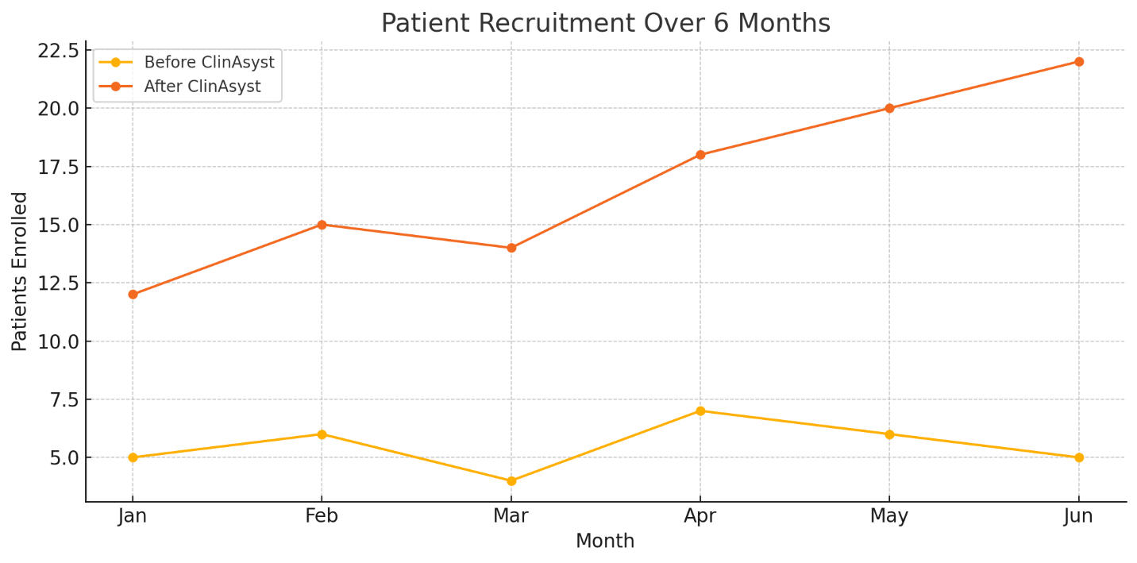

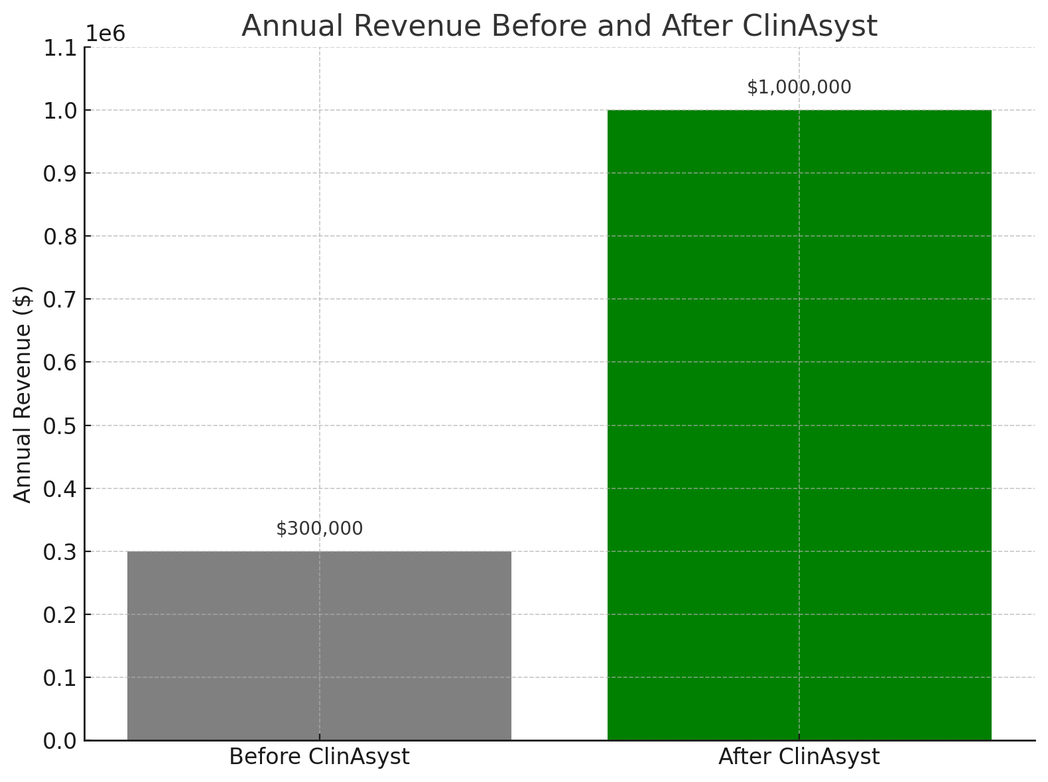

The Outcome: A Leaner, Profitable, and Scalable Research Operation In less than a year, the small physician group transformed its clinical research program:
- Patient enrollment tripled, allowing them to take on more complex, high-enrollment studies.
- Regulatory inspection preparedness improved dramatically, with zero findings in a subsequent sponsor audit.
- Financial performance increased by over 70%, driven by accurate billing, milestone capture, and faster sponsor payments.
- Staff satisfaction rose, as burnout decreased and efficiency improved.
Conclusion: ClinAsyst as a Strategic Investment for Research Growth ClinAsyst is more than a software tool; it is a strategic partner for research sites looking to thrive in a competitive clinical trial environment. Whether you're a small physician group or a large research institution, ClinAsyst offers the flexibility, scalability, and intelligence to elevate your operations.
For clinical research sites and institutions aiming to grow their trial portfolio, improve margins, and maintain compliance, ClinAsyst is the CTMS solution built for your success.
Contact us today to schedule a demo and explore how ClinAsyst can transform your clinical research operations.
Driving Clinical Trial Engagement Through Innovation: How VoCACTIA Simplified SAE Reporting and Boosted Referrals at Our Small Research Site
A Practical Case for ClinAsyst and VoCACTIA
As a small but dedicated clinical research site integrated within a busy physician's office, we've always been committed to contributing meaningfully to the advancement of medicine through clinical trials. But like many small sites, we faced two critical challenges:
- Limited physician engagement in clinical trial activities, particularly when it came to referring eligible patients.
- Inefficient and time-consuming Serious Adverse Event (SAE) reporting processes that created barriers to compliance and slowed our momentum.
That’s when we discovered VoCACTIA, the voice-activated solution embedded within ClinAsyst, a clinical trial management software (CTMS) platform designed for real-world research settings like ours.

The Engagement Challenge: A Familiar Story
Many of our physicians were supportive of research in theory—but in practice, the paperwork, protocols, and compliance tasks made it hard to stay involved. Asking them to stop during clinic hours to file a detailed SAE report or comb through records for potential study referrals just wasn’t realistic.
We needed a solution that:
- Reduced administrative burden on physicians.
- Made reporting and referrals simple and fast.
- Offered a clear incentive for physicians to stay engaged.

Enter VoCACTIA: Voice-Activated Compliance and Trial Investigator Assistant
VoCACTIA transformed how we operate by putting the power of clinical trial participation back into the hands of physicians—literally through their voice.
VoCACTIA is a voice-activated interface within ClinAsyst that allows investigators and sub-investigators to:
- Report SAEs hands-free from anywhere—whether they’re between patients or driving home.
- Dictate and submit information instantly, which gets automatically logged, formatted, and filed according to compliance standards.
- Refer patients to trials effortlessly, simply by saying, “Refer patient to trial ABC123.”
It’s fast. It’s secure. And it meets all compliance and audit requirements—without disrupting clinical care.

How We Used VoCACTIA to Incentivize Engagement
We partnered with ClinAsyst to establish a model where physicians are compensated for each properly reported SAE and every patient referral that leads to enrollment.
This changed the game.
- Physicians began reporting SAEs quickly and accurately, without dreading the paperwork.
- Referral rates increased significantly, as the barrier to action was reduced to just a spoken sentence.
- Engagement grew organically, as clinicians started to see research not as a burden, but as a seamless part of patient care—and a new source of income.

Results After 3 Months of Implementation
- SAE reports increased by 45%, with faster submission timelines.
- Patient referrals jumped 60%, as more clinicians felt empowered to refer.
- Physician participation in research meetings increased, thanks to greater ownership and recognition of their role.
- Overall compliance and sponsor satisfaction improved, with fewer follow-ups needed for missing or delayed SAE data.

ClinAsyst + VoCACTIA: A Tailored Solution for Sites Like Ours
ClinAsyst was built with small-to-mid-size sites in mind. It gives us:
- A user-friendly dashboard for managing all trial activities.
- Integrated scheduling, eSource, and document tracking.
- Real-time site performance analytics.
- And now, with VoCACTIA, a revolutionary way to engage physicians and streamline compliance.
We’re no longer chasing down paper reports or begging for referrals. Instead, we’re scaling our research program, one voice command at a time.

Conclusion: Empower Your Physicians. Accelerate Your Trials.
VoCACTIA isn’t just a tool—it’s a strategic advantage for any research site looking to:
- Increase physician involvement.
- Improve SAE reporting accuracy and speed.
- Grow referral pipelines and trial enrollment.
- Build a culture of proactive research participation.
If you’re a research site or institution looking to elevate your physician engagement and simplify trial operations, ClinAsyst with VoCACTIA is your answer.
Let your physicians speak—and let research thrive.

Contact Us
To schedule a demo or learn more about ClinAsyst and VoCACTIA, visit ClinAsyst.com or email us at info@clinasyst.com.

